A GIANT LEFT ATRIAL MASS: NOT A MYXOMA
C. Gallegos, V. Singh, M. Rivera-Maza, R. Colombo, R.C. Hendel,
University of Miami, Miller School of Medicine, FL, USA

Intracardiac involvement from metastatic tumors causing heart failure symptoms is a rare occurrence. We describe an unusual case of a 25-year-old man who presented with symptoms of heart failure and superior vena cava syndrome. He had a past history of right testicular cancer status post transcrotal orchiectomy. Labs reported increased beta-human chorionic gonadotropin (β-hCG), alpha-fetoprotein, and lactate dehydrogenase (LDH). Chest x-ray demonstrated large, right pleural effusion, and a CT scan of the chest confirmed a mass occupying 2/3 of the right hemithorax invading the left atrium via right pulmonary veins. Transthoracic echocardiogram (TTE) a mobile left atrial mass prolapsing into the left ventricle through the mitral valve. Patient completed chemotherapy for metastatic germ cell (non-seminomatous) tumor, with significant improvement. Upon discharge, he had no further cardiac symptoms and a repeat TTE demonstrated no residual left atrial mass. In conclusion, a non-seminomatous germ cell tumor metastatic to lungs, and extending to the left atrium, is an infrequent and unique cause of heart failure presentation. TTE proved to be an excellent diagnostic and prognostic imaging tool, providing high quality images, and demonstrating the effectiveness of the chemotherapy treatment.

FIGURES
Figure 1. TTE performed on admission. A. Parasternal long axis. B. Apical four chamber views demonstrate a mobile 7.65 x 3.82cm mass (*) in the left atrium prolapsing through the mitral valve into the left ventricle. This mass takes up >85% of the left atrium
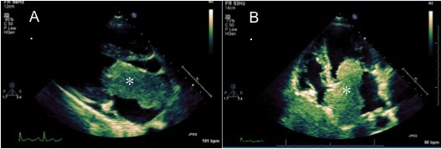

Figure 2. Follow-up TTE after 7 days of starting chemotherapy regimen. A. Parasternal Long axis. B. Apical four chamber views show smaller mobile 5.47 x 3.69 cm mass (*) in the left atrium no longer interfering with mitral valve function. TTE after 6 months after diagnosis demonstrating no residual mass. C. Parasternal D. Apical four chamber view without evidence of left atrial mass.
